UNIT-III

SPLAY TREES
  - Splay tree is self adjusting or self balancing tree data structure.
  - Splay tree is another variant of binary search tree.
  - In a splay tree, the recently accessed element is placed at the root of the tree.

Definition: A splay tree is a self-adjusting binary search tree in which every operation on an element rearranges the tree so that the element is placed at the root position of the tree”.
  - All the operations on a splay tree are involved with a common operation called "Splaying".
  - Splaying: Splaying an element is the process of bringing it to the root position by performing suitable rotation operations.
  - In a splay tree, splaying an element rearrange all the elements in the tree so that splayed element is placed at root of the tree.
  - With the help of splaying an element we can bring most frequently used element closer to the root of the tree so that any operation on those element performed quickly. That means the splaying operation automatically brings more frequently used elements closer to the root of the tree.

Advantages of Splaying:
    - Data accessed once, is often soon accessed again. Splaying does implicit caching by bringing it to the root
    - No heights to maintain, no imbalance to check for. Therefore, Less storage per node, easier to code

SPLAY ROTATIONS
- To splay an element we use sequence of rotation operations.
- Splay rotations are more or less similar to AVL tree rotations and will precede bottom up from node towards the root node.
There are 6 rotations in case of Splay Trees:
- Zig Rotation
- Zag Rotation
- Zig - Zig Rotation
- Zag - Zag Rotation
- Zig - Zag Rotation
- Zag - Zig Rotation
- The splay rotations are performed with regard to the specific node U, its parent parent-U and grandparent grandparent-U, until perhaps root node becomes U.
- The main aim of splaying is to move to access node U, up by two levels at every step.
- To do this we track the path from root node to access node U.
Every time the path turns LEFT is termed as ZIG, and every time the path turns RIGHT is termed as ZAG.
- In this case of single step down the tree the path could be either zig or zag.
- If two steps were considered, the path could be any one of zig-zig, zig-zag, zag-zig, zag-zag.
- Since splaying proceeds bottom up, if the length of the path from root to accessed node u is even, then the rotations appropriate to the two step series i.e., zig-zig, zig-zag, zag-zig, zag- zag are undertaken.
- If the length of the path from root node to access node u is odd, then the rotations may turn out to be one corresponding to a single step series either a zig or zag.

Zig: left path, then corresponding rotation is towards right
Zag: right path, then corresponding rotation is towards left

- Zig Rotation: The Zig Rotation in a splay tree is similar to the single right rotation in AVL Tree rotations

General Notation:
Before splaying | After splaying
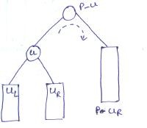 | 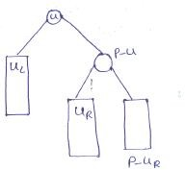

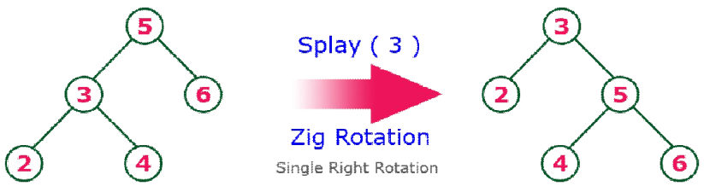
Example:

- Zag Rotation: The Zag Rotation in a splay tree is similar to the single left rotation in AVL Tree rotations.
General Notation:

Before splaying | After splaying
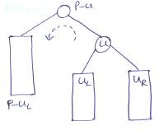 | 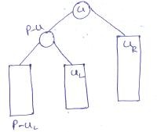

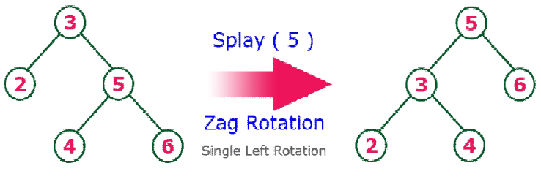
Example:

- Zig-Zig Rotation: The Zig-Zig Rotation in a splay tree is a double zig rotation.
General Notation:

Before splaying | After splaying
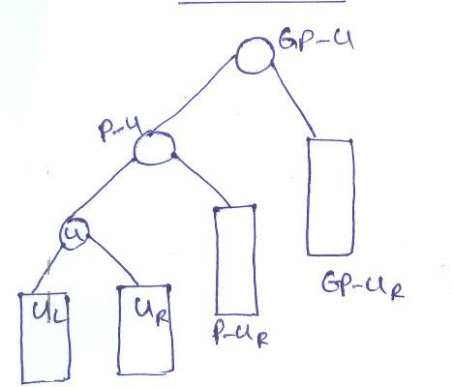 | 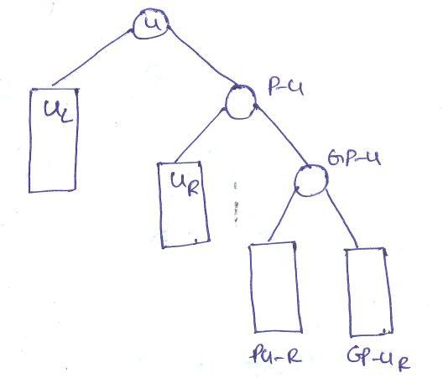

Example:
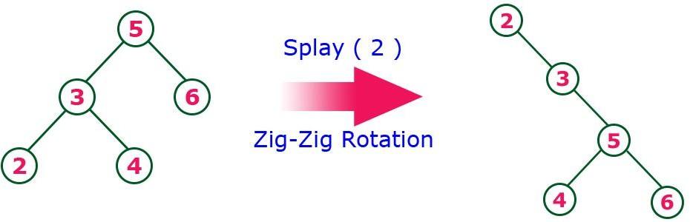
- Zag-Zag Rotation: The Zag-Zag Rotation in a splay tree is a double zag rotation.
General Notation:

Before splaying | After splaying
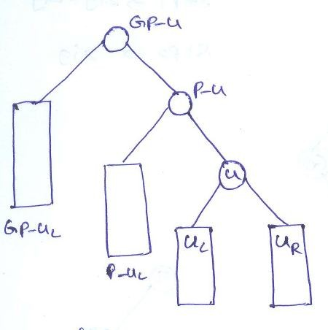 | 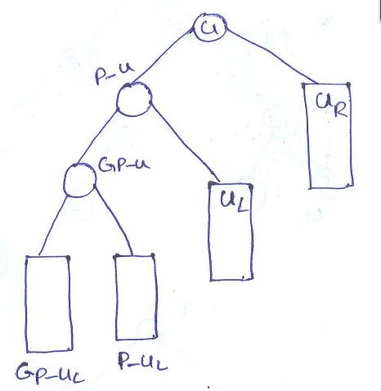

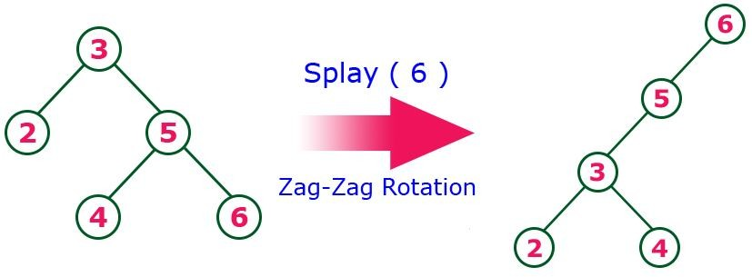
Example:

- Zig-Zag Rotation: The Zig-Zag Rotation in a splay tree is a sequence of zig rotation followed by zag rotation.
  - Rotation 1 is performed at p-u towards left
  - Rotation-2 is performed at gp-u towards right.

General Notation:
Initial tree | After rotation 1 | After rotation 2
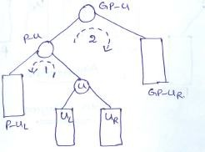 | 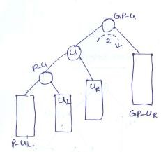 | 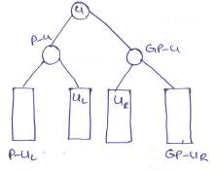
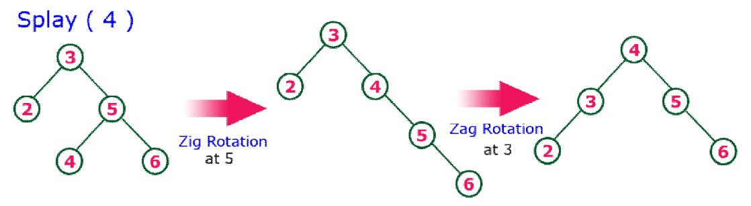
Example

- Zag-Zig: The Zag-Zig Rotation in a splay tree is a sequence of zag rotation followed by zig rotation.
  - Rotation 1 is performed at p-u towards right
  - Rotation-2 is performed at gp-u towards left.

General Notation:

Initial tree | After rotation-1 | After rotation 2
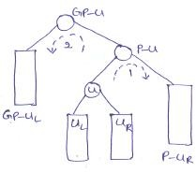 | 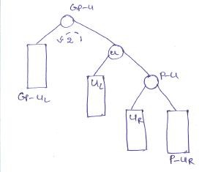 | 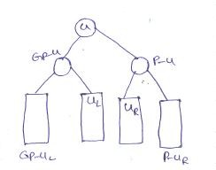

Example:
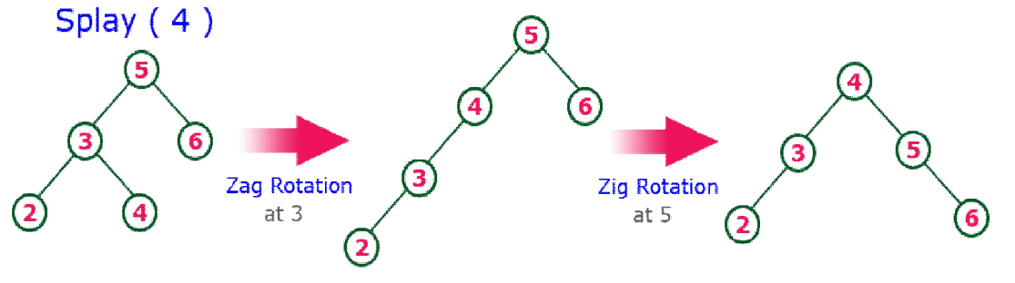

Here zig and zag represents single rotations corresponding to AVL rotations, and zig-zag and zag-zig represents double rotations corresponding to AVL rotations. However, zig-zig and zag-zag are not same as performing two single rotations

